PERFORMANCE TASK
8TH GRADE ELA
ARGUMENT WRITING

Just Because We Can, Should We?

Consider: SCIENCE AND TECHNOLOGY HAVE PROGRESSED QUICKLY IN OUR LIFETIMES. WHEN YOU THINK ABOUT THIS PROGRESS, I WANT YOU TO THINK ABOUT IF THERE SHOULD BE A LINE WE DO NOT CROSS.

Think about: We read “Flowers for Algernon,” watched videos about Human Head Transplants and Face Transplants. Do you think scientists should have complete freedom in their research, or should society and government control research?

Enclosed, you will find:
- links to videos
- printed articles

PLEASE DO NOT WRITE ON THESE PAGES (IF THEY HAVE BEEN PRINTED)

You will also be given the following:
- A note catcher
- A rubric for argument essays
- An argument organizer/ planner
- Directions for the argument essay task

Just because we can, should we?

Should there be a line drawn when it comes to medical and scientific research? Why? Why not?
If there should be limits, how do we as a society decide what is acceptable?

If science/ medicine should have freedom to progress without limit, how do we keep people safe and protected?

PHASE 1: Cryogenics
Watch the video. Note this video was created by a company that sells cryogenic services. It will be very one-sided. Take notes on the video as it proceeds.

https://youtu.be/E7a3oaKKaVs

Another video to watch about the same topic:
https://youtu.be/Duy-W3-Gkhg

Follow the link to a video about the youngest child to be cryogenically preserved:
https://youtu.be/bkPjErxvrC8

On your note catcher make sure you are writing your thoughts and opinions, but also include fact. You can make up your mind later about how you actually feel about this topic.

Phase 2: Cloning

Watch this video about the first dog commercially cloned. Take careful notes.
https://youtu.be/LPxYvoS4uIg

Watch at least a few minutes of this one:
https://youtu.be/7jBa-WRQzzw

Read the following article:
“How Scientists Could Actually Bring Dinosaurs Back to Life”

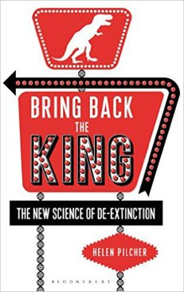
On Jan. 6, 2000, a wild mountain goat named Celia was crushed to death by a falling tree on the cliffs of the Spanish Pyrenees — thus beginning her march into history Celia was a bucardo — a specific species of wild goat — and, as it happens, the final one. But a group of Spanish scientists had other ideas. Ten months earlier they had taken a sample of Celia’s tissue, in the hopes of bringing her species back from extinction. If it worked, notes science journalist Helen Pilcher in her new book “Bring Back the King: The New Science of De-extinction” (Bloomsbury Sigma), it “would mark a defining moment in the history of the Earth; an end to the finality of extinction.”
Two years later, “cells with Celia’s DNA were injected into goat eggs that had been stripped of their own genetic material. After a brief electrical jolt, the eggs then began to divide.” The embryos were implanted into the wombs of “surrogate mother goats,” and while most of the pregnancies failed, one did not.
History was made on July 30, 2003, when one of Celia’s clones was born, marking the first time a species ever came back from extinction. Sadly, her health did not hold up. Her lungs had been “grossly deformed” and she died seven minutes later — marking the first time ever a species had gone extinct twice.
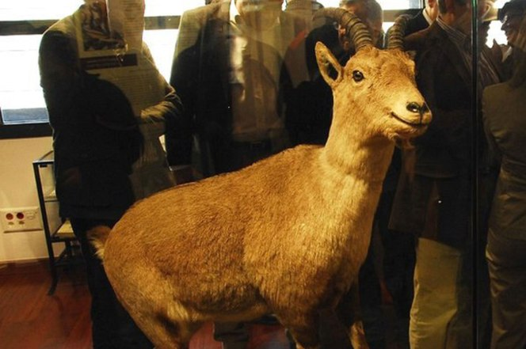
Many of us were introduced to the concept of “de-extinction” by the movie “Jurassic Park,” which resurrected the dinosaurs to horrific ends.But the idea behind the film wasn’t the wild invention of a Hollywood screenwriter. Pilcher writes that in the 1980s, John Tkach, founder of a “secretive cabal of scientists and clinicians in Bozeman, Montana” calling themselves the Extinct DNA Study Group, posed an intriguing thought experiment.
“What if, many millions of years ago, there had been a hungry mosquito that dined on a dinosaur then became trapped in amber, with its last supper still inside its stomach. If one could recover a dinosaur blood cell from inside that mosquito and then transplant it into an egg that had had its own DNA removed,” it might be possible to “grow a dinosaur.” This theory might have been far-fetched, but it wasn’t totally crazy. Entomologist George Poinar from the University of California at Berkeley spent his career studying million-year-old insects preserved inside tree resin that had hardened into amber. Usually they were intact on the outside but the insides were “a disappointing mess,” but in 1980, he came across a fly that “defied expectation,” with cells still intact after 40 million years. This was exactly what Tkach had theorized about.
A modern living dinosaur is not a fantasy.
Poinar’s findings, once published, excited the scientific community, including “a tall, gangly man” who visited his lab to ask questions about “bringing back life forms in amber.” Poinar thought nothing of it until years later, when he was informed that he’d been thanked in the back of a new book, soon to be a movie, called “Jurassic Park.” The book’s author, Michael Crichton, had been his tall, gangly visitor and “used [his visit] as the scientific basis for his novel.”
So where does the effort to de-extinct the dinosaurs sit today, decades later? “A modern living dinosaur is not a fantasy,” writes Pilcher in her book. But while there are respectable scientists who believe it can be done, she also makes it clear that we shouldn’t hold our breath. After all, finding the raw material to create a dinosaur is a tremendous challenge, to say the least. “To de-extinct an animal, you need a source of that animal’s DNA,” writes Pilcher. “But all we have for dinosaurs are their remains, cast in stone.”
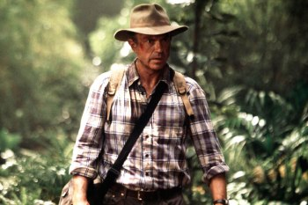
MoSam Neill’s character in “Jurassic Park” is based on real-life de-extinction scientist Jack Horner. His claim was proved in 2012 “by a study that found that DNA has a half-life of just 521 years.”This means that “after 6.8 million years, every single link would be destroyed, making the recovery of DNA from fossils any older than this completely impossible.”It turned out there had been no DNA in the fossils from the 1990s discoveries, and that the experiments had accidentally “amplified bits of contemporary DNA from the surrounding environment.”
The dinosaurs went extinct around 65 million years ago. So while a recently announced find of a 99-million-year-old dinosaur tail that included bones, soft tissue, and feathers, all cast in amber, was exciting for scientists studying the ancient animals, DNA breakdown means it won’t help resurrect them. Still, Schweitzer believes that discovering dinosaur DNA one day might be possible. “If you can get DNA from a 700,000-year-old fossil, why not a million-year-old one,” she told Pilcher, “and if you can get DNA from a million-year-old fossil, why not one that is 7 or even 70 million years old?”
Modal There are some scientists — including Schweitzer’s boss, Jack Horner, the scientific adviser for “Jurassic Park” and the inspiration for Sam Neill’s scientist character in the film — who wonder if it might be possible to resurrect dinosaurs in other ways.
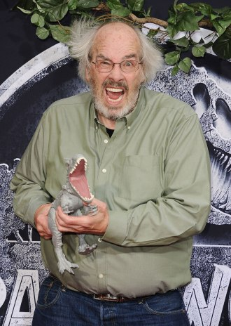
“By tinkering with the development programs of embryonic chickens, he hopes to persuade them to bring out their inner dinosaur; to develop dinosaur-like features like teeth and tails.” In short, Horner is trying to hatch real-life chickens that are more dinosaur-like. Even so, the odds of de-extincting the dinosaur are about as good as one showing up as your next Uber driver.
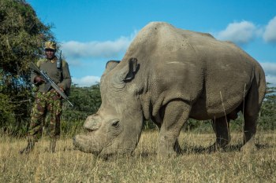
Scientists are currently trying to de-extinct species as diverse as the dodo, the passenger pigeon and the woolly mammoth but have hit road­blocks including a lack of DNA, no proper incubation environment and the risk of cruelty to living related species that would need to serve as surrogates. On a more positive note, Pilcher writes that the science of de-extinction may help prevent endangered species from going extinct in the first place.
Modal Pilcher writes that even if de-extinction never works, the efforts might help to save endangered species—like the northern white rhino, of which only three remain. “There are a number of projects out there where people are deliberately collecting cells from endangered animals, [including] collecting roadkill and taking cells from that,” says Pilcher. “We also have museums filled with all these stuffed animals, and while they don’t have living cells, very often they’ll have dead cells which have DNA.”
She notes, for example, that there are only three northern white rhino left in the world, which aren’t able to reproduce due to age and other factors.
Scientists have already taken skin cells from the rhinos in the hopes of one day converting the material first into stem cells, then into eggs that can be fertilized with semen samples, which they’ve also extracted.
According to Pilcher, it’s not inconceivable that scientists could breed a northern white rhino in a test-tube sometime in the next three to 10 years.Meanwhile, if it’s dinosaurs you really want to see brought back to life, you’re better off marking your calendar for 2018, when the next “Jurassic Park” sequel is scheduled for release.

Phase 3: Other Possibilities?

On Phase 3 of your note catcher, write your thoughts and opinions of the following:

Are these total Science Fiction?
https://youtu.be/f8D2NIGEJW8

https://youtu.be/rL6RRIOZyCM

This seems like it should be Science Fiction...but it isn’t.
https://youtu.be/KFSlmb45QtU

Think about the short story “Flowers for Algernon” and the artificial increasing of intelligence. Is it really so far-fetched?

STUDENT HANDOUTS NOTE CATCHER
Take careful notes to prepare for your essay
Phase 1-Cryogenics
Notes/ Thoughts | Positives | Negatives
Phase 2--Cloning
Notes/Thoughts | Positives | Negatives
Phase 3--Other
Notes/Thoughts | Positives | Negatives

PERFORMANCE WRITING TASK
Directions: Please respond to the prompt below in writing. Please use your note catcher, the information from your RACE paragraph on Human Experimentation, and the short story “Flowers for Algernon” to inform your writing. Your essay will be a total of five or six paragraphs.

Writing Prompt:
Because they want the opinion of future scientists, the local newspaper editor has asked you to write an editorial statement for the newspaper about the ethics in Scientific Research.

Just because we can, should we?

Should there be a line drawn when it comes to medical and scientific research? Why? Why not?
If there should be limits, how do we as a society decide what is acceptable?

If science/ medicine should have freedom to progress without limit, how do we keep people safe and protected?

After reading the provided texts and viewing the videos on the topic, write an argumentative essay (at least five paragraphs) that addresses the question and supports your claim with evidence.

A Summary of An Argument Essay
Introduction-Start with a strong lead. Get your reader’s attention. Then, lead your reader to the main idea. At the end of this paragraph, you will state your CLAIM.
Body Paragraphs-One paragraph for each Data/Warrant. You need two to three of these. USE IN-TEXT CITATIONS TO REFER TO PHASES.
Counterclaim/Rebuttal-Discuss these items in ONE paragraph.
Conclusion-Wrap it up. Summarize. Leave your reader with a strong impression.

ARGUMENT ORGANIZER
Directions: Prepare two or three pieces of evidence (data) and their explanation (warrant) to use in your writing. Don’t forget you have these definitions and examples on other papers. USE IN-TEXT CITATIONS TO REFER TO EACH PHASE #

Claim goes at the end of the introduction. Start with attention-getting opener.
Claim-What you are trying to prove to be true. (Complete sentence that could stand alone): ______________________________
_____________________________________________________________________________________
You may use either 2 or 3 pieces of data. It is up to you.
Data (Evidence or Reason your claim is true. These are the “facts”)  __________________________  __________________________  __________________________  __________________________ | Data (Evidence or Reason your claim is true. These are the “facts”)  ___________________________  ___________________________  ___________________________  ___________________________ | Data (Evidence or Reason your claim is true. These are the “facts”)  ___________________________  ___________________________  ___________________________  ___________________________

Warrant (Details that show how the evidence proves you are right. Pretend I don’t understand what you are trying to say.)  - ______________________  - ______________________  - ______________________  - ______________________ | Warrant (Details that show how the evidence proves you are right. Pretend I don’t understand what you are trying to say.)  - ______________________  - ______________________  - ______________________  - ______________________ | Warrant (Details that show how the evidence proves you are right. Pretend I don’t understand what you are trying to say.)  - ______________________  - ______________________  - ______________________  - ______________________

Counterclaim (The Opposing Opinion)  Some may say that...  ___________________________________  ___________________________________  ___________________________________  ___________________________________  ___________________________________  ___________________________________ | Rebuttal (My response to the Counterclaim)  However….  ______________________________________________  ______________________________________________  _____________________________________________  _____________________________________________  _____________________________________________  _____________________________________________
All that is left is the conclusion paragraph--make it powerful!
 | 4 | 3 | 2 | 1
INTRODUCTION  Background/History  Define the Problem  Thesis Statement | Well-developed introductory paragraph contains devices to create interest, and a well-formed, properly placed thesis statement (Claim). | Introductory paragraph creates interest, and states the problem, but does not explain using details. States the thesis/claim of the paper. | Introduction states the thesis but does not adequately attempt to create interest. The problem is stated, but lacks detail. | Thesis and/or problem is vague or unclear. Writer does not attempt to create interest | ____
MAIN POINTS  Body Paragraphs—3  WITH AT LEAST 3-5 SENTENCES EACH | Three or more main points are well developed with supporting details. (Data and Warrant) It is obvious that a plan was developed to create sound, logical development. | Three or more main points (Data and Warrant) are present but may lack detail and development in one or two. Overall, the paper is logically developed. | Three or more main points, but all lack development. There are one or two examples that are not sound, logical argument. Paper itself is repetitious, contradictory, or shows lack of organizational planning. | Fewer than three main points, with poor development of ideas. Obvious lack of logical argument throughout. There are many examples of poor organization. | ____
COUNTERCLAIM/ REBUTTAL PARAGRAPH | COUNTER CLAIM IS CLEARLY PRESENTED. A POWERFUL AND MEANINGFUL REBUTTAL IS PROVIDED. | COUNTERCLAIM AND REBUTTAL ARE PRESENT AND EASILY IDENTIFIED | COUNTERCLAIM AND/OR REBUTTAL MAY NOT BE CLEAR OR EASILY UNDERSTOOD. | ONE OR BOTH OF THESE ELEMENTS MISSING. | ____
CONCLUSION—3-5 SENTENCE MINIMUM | Conclusion summarizes the main topics without repeating previous sentences. Concluding thought is interesting and well-thought out. | Conclusion summarizes main topics. The paper is obviously coming to an end. | Conclusion summarizes main topics, but is repetitive. An ending is not clearly signaled. | Conclusion does not adequately summarize the main points. | _____
Conventions: Sentence Structure Punctuation Capitalization Spelling  INK  Sentence Variety  MARGINS INDENTED | Sentence structure is correct and sentences are varied (beginnings, lengths, structures). Punctuation, spelling and capitalization are correct. Paper is written neatly in ink, and has correct margins and indentations. No other mechanical errors.  IN-TEXT CITATIONS ARE CORRECT | Sentence structure is generally correct. Some awkward sentences do appear. Sentences show some variety, with an occasional (1 or 2) repetition of sentence beginnings or a number of consecutive sentences of the same length or type. In-Text citations are present, but may be incorrect. | Work contains some sentence errors (2 or 3) and grammatical errors. There are three or four errors in punctuation, spelling, capitalization, and/or other mechanics. Many consecutive sentences begin with the same words, are of the same length or the same sentence construction. Paper does not have correct indentation and/or margins. In-text citations are incorrect | Work contains multiple incorrect sentence structures (more than 3). There are many errors in punctuation, spelling, capitalization,etc. Often writing is awkward due to many examples of poor/incorrect word choice. No citations | ____
 |  |  |  | Total----> | ____

Grade Equivalents: A = 20-18 B = 17-16 C = 15-14 D = 13-12 F = 11 or below GRADE: _______________

SAMPLE ARGUMENT ESSAY

On the night of July 16, 1918, the young Duchess Anastasia Romanov of Russia was supposedly killed with her family. Many people, however, believe that Anastasia survived the attempt on her life. Evidence has come up over the years that effectively provides proof for this claim. Three pieces of evidence that prove Duchess Anastasia lived through that fateful night are the fact that two of the Romanov bodies were missing from their shallow graves, the law authorities discovered a girl with identical birthmarks to Anastasia, and the fact that the remaining Romanov’s recognized the girl.
On the night in which Anastasia was supposedly killed, several soldiers were present. Many claimed that Anastasia and her brother, Alexei, showed signs of life. These same people also claimed that the soldiers didn’t bother to finish them off, thinking they would die in the night. By the time the somber procession reached the grave site, the life signs were very faint, so faint that the soldiers who buried the mutilated bodies decided that the two Romanov’s would die in their shallow graves. After the bodies were disposed of, the soldiers went home to their families or back to their jobs, not bothering to make sure that Anastasia and Alexei died. Most of the Romanov bodies were discovered for the first time since the murder in 1991. The searchers who were removing the bodies realized that two of the seven bodies were missing (Phase 1). DNA testing proves that the two missing bodies were those of Anastasia and Alexei. At first, officials believed that the bodies were dug up by wild animals or another force, but the graves did not look like they were touched by animals. The graves looked as though the bodies may have been removed by human hands, which could have been the hands of Anastasia and Alexei (Phase 1).
In 1920, a young woman named Anna Anderson was found trying to drown herself in the Berlin River (Phase 3). Further examination showed that Anna shared many of the same characteristics as the lost Duchess Anastasia. Just one of these qualities is a toe deformity that was in the same spot as one Anastasia had. When asked how she received the deformity, Anna replied that she received it when a carriage ran over her toe. This was how Anastasia received her toe deformity. Anna also shared many birthmarks with the young duchess. A mole here, a spray of freckles there, each the same as Anastasia. When the deranged young woman was brought to her supposed family, she shared many of the family memories only Anastasia could remember (Phase 3). She showed details about some of her closest uncles that even some of her family did not know (Phase 3). Anna was accepted by many of the family, and many claimed that she was so like Anastasia that she had to be the long lost duchess.
Some people might claim that Anna Anderson could have conned everyone with her performance as Anastasia Romanov, using help from Anastasia's family to convince the public. However, Anna shared memories that not even some of her family knew. Anna could have only remembered these things if she was Anastasia. Anastasia’s family wanted her back, and they had no reason to lie or cheat. Little Anastasia was a family favorite, and she was greatly missed by all who knew her.
Anastasia Romanov survived the attempt on her life. She lived through the night, while her family lay dead in shallow graves. Anna Anderson and the fact that both Anastasia and Alexei showed signs of life on their execution night prove that she lived. This story is a powerful event because it shows that no matter how pampered or protected one might be, there is always someone eager to prove all of the facts wrong. But in other cases, this story is one of true survival and spirit. Anastasia was shot, stabbed, and beaten to ribbons, but still she persisted. She made her way out of that grave and made a life for herself. Anastasia Romanov should be looked at as one of many who were fortunate enough to have a second chance at life, and as one of the strongest young women who suffered abuse and lived to tell about it.

NOTES:

- Do not use the pronoun “You”
- Do not use “Think”
- Do not refer to “I am going to prove…”
- Do not say “In this essay …” or “In that sentence….”
- 5-6 Paragraphs long
- Edit CAREFULLY
- Don’t use the word “stuff” in formal writing
- Commas are nice. Use them.
- Double space Final Drafts
- Times New Roman 12 point font.
- Write out numbers smaller than ten.
- Read your paper out loud to yourself. Mark what needs work--then go back.
- Have a friend read your paper out loud to you. Stop when you hear a problem.
- Use powerful word choices. Lots of details. Don’t list...describe.

